Creamy Roasted Garlic & Kale Soup with Cauliflower
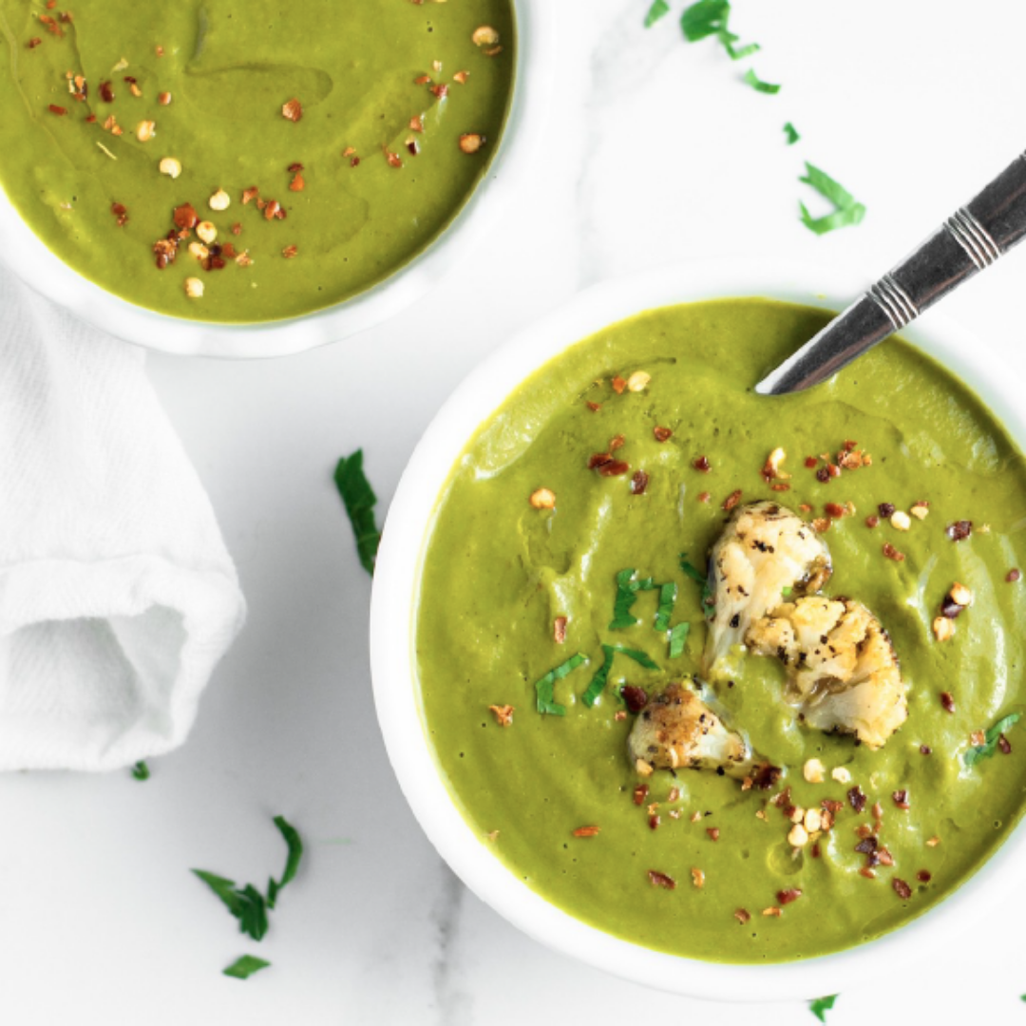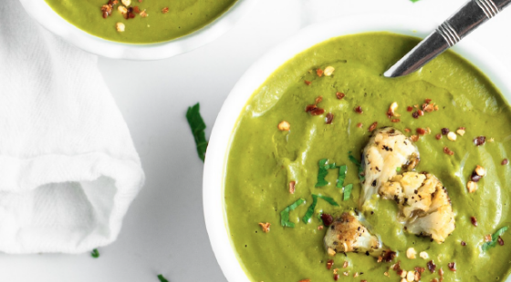
Based on 2015 estimates nearly 1 in 2 Canadians (45% of men and 43% of women) is expected to develop cancer (link to other cancer post) during their lifetime. This can be seen as a frightening statistic!
However, if we also understand that that approximately 85% of cancers are caused by environmental factors, including diet and lifestyle (link to other cancer post), we can transform that initial fear into a feeling of empowerment to improve our own individual health!
This simple and delicious soup recipe combines several powerhouse, cancer-preventative foods into one enjoyable dish!
Mechanistic studies have provided evidence that the sulphur compounds in garlic, onion and other foods in the allium family alter tumour development. Individuals with diets rich in garlic and onion are at a decreased risk of developing cancer, most particularly cancers of the digestive tract. Garlic also contains compounds that can boost the number of immune cells present in the blood. A healthy immune system is one that can help protect us from developing cancer.
Like garlic and onion, cauliflower contains potent sulphurous compounds that help prevent cancer. Additionally, cauliflower contains indoles, including indol-3-carbinol which have been found to inhibit cancer development in many organs and organ systems such as breast, colon, liver and lung.
Dark leafy greens such as the kale found in this recipe, are high in antioxidants which can boost the body’s own defenses to help prevent the damage to DNA that causes cancer. Plus, kale contains plenty of fibre and consuming adequate dietary fibre is well-known to reduce the risk over several cancers including bowel cancer.
So, try it out… It’s an easy side dish that’s not only healthy, but sure to impress!
And if you like recipes like this one, you will LOVE our FREE 1-day Cancer Prevention Meal Plan, which is packed with 6 fantastic meals formulated to include loads of nutrients and antioxidants that may help prevent cancer. Check it out! (link) – would be good to include a promo image here

8 ingredients · 1 hour 15 minutes · 4 servings
Ingredients
12 Garlic (cloves, peeled and trimmed)
1 Yellow Onion (large, roughly chopped)
1 head Cauliflower (sliced into florets)
3 tbsps Extra Virgin Olive Oil (divided)
1 1/3 tbsps Italian Seasoning
1 tsp Sea Salt
8 cups Kale Leaves (packed)
3 3/4 cups Organic Vegetable Broth (divided)
Directions
1. Preheat oven to 400ºF (204ºC) and line a baking sheet with parchment paper.
2. Arrange the garlic cloves, onion and cauliflower on the baking sheet. Drizzle with half of the olive oil, Italian seasoning and salt. Using your hand or a spatula, toss until vegetables are evenly coated in the spices. Roast for about 40 minutes or until very tender and caramelized, flipping halfway through.
3. When vegetables are just about done, heat remaining olive oil in a large soup pot over medium heat. Add the kale and 1/2 of the vegetable broth to the pot and cover. Let steam for 2 minutes, or until kale is wilted and tender.
4. Add the roasted vegetables and remaining vegetable stock in with the wilted kale. Bring soup to a gentle boil then remove from heat.
5. Puree soup in batches in a high-speed blender until smooth and creamy. Divide into bowls and enjoy!
Nutritional Information
Amount per serving:
Calories - 176
Carbs - 17g
Fiber - 6g
Sugars - 7g
Protein - 5g
Fat - 11g

Garlic and onion: Their cancer prevention properties. https://www.ncbi.nlm.nih.gov/pmc/articles/PMC4366009/

- Hecht SS. Inhibition of carcinogenesis by isothiocyanates. Drug Metabolism Reviews 2000;32(3-4):395-411.
[PubMed Abstract]
- Murillo G, Mehta RG. Cruciferous vegetables and cancer prevention. Nutrition and Cancer 2001;41(1-2):17-28.
[PubMed Abstract]

AICR/WCRF. Diet, Nutrition, Physical Activity and Cancer: A Global Perspective, 2018.

